

Methodology

Staff of the Council LEAD Project drafted an introductory letter to Council General Managers and an initial survey, to obtain baseline information, in April 2001. These were emailed to the Reference Group and members of the Steering Committee in time to be reviewed at the 24th April Steering Committee Meeting. Very useful comments were received and incorporated although the recommendation that the survey be only one page long meant that some useful suggestions could not be included in this survey. The following suggested questions were not able to be included (even when the font was reduced to 10 point!):

- Does your Council have OH&S (Occupational Health and Safety) policies or requirements for your staff when working in potential lead risk situations? [Suggested by Robert Verhay, LGSA]

- Are you aware of any lead sources (industrial and other) in your Council area? [Alwyn Piggott, WorkCover Authority]

- Are you aware of any lead education activities conducted by anyone else in your area – who? AND What are the primary sources of lead in your area that you are aware of? We could list common options for ticking, eg radiator repairers. [Colin Menzies, The Public Practice - consultants to the Council LEAD Project].

The letter and survey were finalised and emailed to every NSW Council's General Manager on Monday 28th May, ie 173 Councils, using the email address provided on the Dept of Local Government website. A mopping-up exercise involved either re-emailing or posting to approximately 12 councils whose servers were down (or stolen!), whose server blocked attachments or for whom we had to phone for an updated email address.

After one week, 20 surveys had been returned so 153 hard copies of the letter and survey were posted to the remaining General Managers on Monday 4th June 2001.

After another week and the Queens Birthday public holiday, altogether 50 surveys had been returned and we began the task of phoning the remaining Councils in alphabetical order. In no time we determined how difficult it is to locate the person who had dealt with the letter to the General Manager and in many cases it seemed the survey had not even been forwarded to an appropriate person, let alone filled in. So we prioritised the Councils that would be phoned by:-

- starting with the 20 Councils having the largest populations, ie more than 1.5% of the total population of NSW each (see table below). Of the 20 largest Councils, 8 had already returned the survey, so the remainder were phoned on Wednesday 13th June.

 | ORGNAME | POPULATION | %
 | Bankstown City Council | 172213 | 2.7
 | Blacktown City Council | 260332 | 4.0
 | Campbelltown City Council | 149990 | 2.3
 | Canterbury City Council | 139028 | 2.1
 | Fairfield City Council | 191239 | 2.9
 | Gosford City Council | 160167 | 2.4
 | Ku-ring-gai Council | 108127 | 1.6
 | Lake Macquarie City Council | 184346 | 2.8
 | Liverpool City Council | 149257 | 2.3
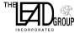


Return to: The LEAD Group Inc. PO Box 161 Summer Hill NSW Australia 2130

Phone: (02) 9716 0014 Email: www.leadsafeworld.com/about-us/contact-us/ Web: www.lead.org.au

Initial Survey Results July 23 July 2001 Page 1 of 11
Newcastle City Council |  | 140955 | 2.1
Parramatta City Council |  | 146405 | 2.2
Penrith City Council |  | 174745 | 2.7
Randwick City Council |  | 126705 | 1.9
Ryde City Council |  | 97818 | 1.5
Sutherland Shire Council |  | 213131 | 3.2
The Council of the Shire of Baulkham Hills |  | 136568 | 2.1
The Council of the Shire of Hornsby |  | 150029 | 2.3
Warringah Council |  | 134744 | 2.0
Wollongong City Council |  | 187003 | 2.8
Wyong Shire Council |  | 132417 | 2.0

CLP Init Survey Results Query

100
90
80
70
60 |  |  |  |  |  |  |  |  |  |  |  |  |  |  |  |  |  |  |  |  |  |  |  |  |  |  | Country
50 |  |  |  |  |  |  |  |  |  |  |  |  |  |  |  |  |  |  |  |  |  |  |  |  |  |  | Metro
 |  |  |  |  |  |  |  |  |  |  |  |  |  |  |  |  |  |  |  |  |  |  |  |  |  |  | Shire
40 |  |  |  |  |  |  |  |  |  |  |  |  |  |  |  |  |  |  |  |  |  |  |  |  |  |  | Shire
30
20
10
0
 |  |  |  | 18 - Lack Resources |  |  |  |  |  | 19 - Lack Skills |  |  |  | 20 - Lack Clr Support |  |  |  |  | 21 - Other Priorities
 |  | Country |  | 88 |  |  |  |  |  | 14 |  |  |  | 4 |  |  |  |  | 62
 |  | Metro |  | 50 |  |  |  |  |  | 21 |  |  |  | 4 |  |  |  |  | 59
 |  | Shire |  | 86 |  |  |  |  |  | 42 |  |  |  | 5 |  |  |  |  | 67

- Secondly, we targeted the next 20 Councils, regardless of population, that have a known high lead risk, that is:- lead mining areas and inner Sydney Councils plus the Blue Mountains (see table below). Of these, 2 had already returned the survey so the remainder were phoned. One of the Council officers reported that it had taken 9 days for the survey to come to him from the GM's office. Altogether from this round of phonecalls, 12 letters and surveys had to be re-emailed as they could not be found!

ORGNAME | POPULATION | %
Auburn Council | 58247 | 0.90
Blue Mountains City Council | 76541 | 1.18
Broken Hill City Council | 20429 | 0.31
Burwood Council | 30598 | 0.47
City of Canada Bay Council | 60926 | 0.94
Cobar Shire Council | 5474 | 0.08
Hurstville City Council | 72217 | 1.11
Kogarah Municipal Council | 52826 | 0.81
Leichhardt Municipal Council | 62609 | 0.96
Marrickville Council | 79445 | 1.22
North Sydney Council | 58849 | 0.91
Initial Survey Results July | 23 July 2001 |  | Page 2 of 11
Rockdale City Council | 91742 | 1.41
South Sydney City Council | 87116 | 1.34
Strathfield Municipal Council | 28674 | 0.44
The City of Sydney | 24907 | 0.38
The Council of the City of Botany Bay | 36073 | 0.55
The Council of the Municipality of Ashfield | 42181 | 0.65
The Council of the Municipality of Hunters Hill | 13856 | 0.21
Willoughby City Council | 61608 | 0.95
Woollahra Municipal Council | 54773 | 0.84

- When we realized that several Council LEAD Project Liaison Officers had stated that there was no-one at their Council who had done the Lead Reference Centre (LRC) training course offered to all Councils in 1999 - even though our list from the LRC had a person from their Council on it, we realized that the list needed updating. So we decided to phone those Councils who both had not yet responded to the survey but who had had a member of staff trained two years ago in lead by the LRC, as the third priority for reminder calls. This way we could update our list and chase up the surveys in the one phonecall.

- Fourthly, we knew that the LGSA's survey about Ecologically Sustainable Development reported on the responses from Councils by breaking them up into 3 categories - Metro Councils, Shires and Country Councils - based on their membership of either the Local Government Association (LGA - both Metro & Country) or the Shires Association. It seems that generally, Shires are mainly rural Councils whereas Councils that are members of the LGA are metropolitan Councils or Councils based around larger country towns. There are 23 exceptions to the rule that a Council designated as a "Shire" by LGSA (due to membership of the Shires Association) has the word "Shire" in its name:- 3 Shire Councils (Baulkham Hills, Hornsby and Sutherland) are "Metro" Councils, ie are in the Sydney metropolitan area; 11 "Shires" do not have the word "Shire" in their name (Griffith City, Pristine Waters, Walcha, Kyogle, Cabonne, Oberon, Deniliquin, Boorowa, Wellington, Richmond Valley, and Bombala Councils); and 9 Councils with "Shire" in their name, are classified by LGSA as being "Country" councils (Mudgee, Maclean, Shellharbour, Wollondilly, Wingecarribee, Muswellbrook, Bellingen, Wyong and Byron Shire Councils). So we have used the LGSA's classification system and determined that our fourth priority group are "Metro" councils that have not been among any of the above priority groups, followed by "Country" councils, due to the likelihood that pre-1970 buildings would be a more common occurrence in these council areas, than in low-population rural "Shires".

At the end of the fourth week, when we had received 104 surveys, we re-contacted those among the 40 highest priority Councils from whom we did not have a survey. Thus 2 of the

20 Councils with the highest population and 6 of the 20 next councils with high lead risk were prompted with another phonecall. We stopped prompting when we had 110 surveys returned.

Baseline information - Results of Survey

Results were analysed according to whether the councils were Metro (Sydney metropolitan), Shire or Country.

Overall response rates were as follows:-

- 33 of the 37 Metro councils sent back surveys (a response rate of 89% for the Metro councils), although two Metro councils (Lane Cove and Canada Bay) returned two surveys each

Initial Survey Results July 23 July 2001 Page 3 of 11
- 50 of the 96 Shires (52%), and

- 35 of the 40 Country councils (87%) responded,

- so the total was 118 surveys or 116 councils out of the total of 173 councils (an overall response rate of 67%).

Ways Council is active in lead safety

Responses to the questions about ways the council is active in lead safety were mostly either "yes" or "no" as follows:

- Council has adopted a lead-safety Policy Statement [Y/N]

- Copy of Lead-Safety Policy Statement supplied [Y/N]
- Council has discussed lead in a State of Environment Report [Y/N]

- Copy of SoE supplied [Y/N]
- Council has Lead Management Plans or guidelines for council owned or operated properties? [Y/N]

- Copy of Lead Management Plan supplied [Y/N]
- Council has a designated officer to monitor lead issues [Y/N]

- Council has a planning policy or document dealing with lead [Y/N]
- Copy of planning policy or document dealing with lead supplied [Y/N]

- Council has organised community awareness activities on lead (eg. public displays, leaflets)? [Y/N]

- Council has an officer who attended the regional workshop on Lead Management held by the NSW Lead Reference Centre in 1999? [Y/N]

- Answer to above complies with LRCs list of council officers trained [Y/N]

- Council has issued clean up or prevention orders under the POEO Act 1997 [Y/N]
- If “yes” to previous, number issued in the six months 1 July to 30 Dec. 2000 [NUMBER FIELD]

- Council has a Council website with lead information or links? [Y/N]
- If Council has a website, is there a link to The LEAD Group’s website (www.lead.org.au)? [Y/N]

- Other (specified as) [TEXT FIELD]

Note that Question 12 had to be answered by Council LEAD Project staff in response to the answer given to Question 11 and the information provided to us by the Lead Reference Centre, about who attended their workshops.

Remembering that 100% of Metro surveys returned is 33 surveys, 100% of Shires surveys is 50 Shires and 100% of Country surveys is 35 surveys, the following percentages within each category of council represents the "Yes" results for the above Yes/No questions:

Initial Survey Results July 23 July 2001 Page 4 of 11

CLP Init Survey Results Query

60
50
40
 |  |  |  |  |  |  |  |  |  |  |  |  |  |  |  |  |  |  |  |  |  |  |  |  |  |  |  |  |  |  |  |  |  |  |  |  |  |  |  |  |  |  |  |  |  |  |  |  |  |  |  |  |  |  |  |  |  |  |  |  |  |  |  |  |  |  |  | Country
30 |  |  |  |  |  |  |  |  |  |  |  |  |  |  |  |  |  |  |  |  |  |  |  |  |  |  |  |  |  |  |  |  |  |  |  |  |  |  |  |  |  |  |  |  |  |  |  |  |  |  |  |  |  |  |  |  |  |  |  |  |  |  |  |  |  |  |  | Metro
 |  |  |  |  |  |  |  |  |  |  |  |  |  |  |  |  |  |  |  |  |  |  |  |  |  |  |  |  |  |  |  |  |  |  |  |  |  |  |  |  |  |  |  |  |  |  |  |  |  |  |  |  |  |  |  |  |  |  |  |  |  |  |  |  |  |  |  | Shire
20 |  |  |  |  |  |  |  |  |  |  |  |  |  |  |  |  |  |  |  |  |  |  |  |  |  |  |  |  |  |  |  |  |  |  |  |  |  |  |  |  |  |  |  |  |  |  |  |  |  |  |  |  |  |  |  |  |  |  |  |  |  |  |  |  |  |  |  | Shire
10
0
 |  |  |  | 01 - |  |  | 02 - |  |  | 03 - |  |  |  |  | 04 -
 |  |  |  | Lead |  |  | Policy |  |  |  | SoE |  |  |  | SoE |  |  |  |  | 05 - |  |  |  | 06 - |  |  |  | 07 - |  |  |  | 08 - |  |  |  | 09 - |  |  |  |  | 10 - |  |  |  | 11 - |  |  |  |  | 12 - |  |  |  |  | 13 - |  |  |  |  | 15 - |  |  |  | 16 -
 |  |  |  | safety |  |  | suppli |  |  | report |  |  |  |  | suppli
 |  | Country |  | 5 |  |  | 5 |  |  |  | 5 |  |  |  | 0 |  |  |  |  | 5 |  |  |  | 0 |  |  |  | 18 |  |  |  | 0 |  |  |  | 0 |  |  |  |  | 31 |  |  |  | 22 |  |  |  |  | 44 |  |  |  |  | 18 |  |  |  |  | 0 |  |  |  | 0
 |  | Metro |  | 0 |  |  | 0 |  |  |  | 19 |  |  |  | 19 |  |  |  |  | 13 |  |  |  | 0 |  |  |  | 13 |  |  |  | 13 |  |  |  | 13 |  |  |  |  | 50 |  |  |  | 19 |  |  |  |  | 50 |  |  |  |  | 26 |  |  |  |  | 13 |  |  |  | 0
 |  | Shire |  | 0 |  |  | 0 |  |  |  | 6 |  |  |  | 3 |  |  |  |  | 3 |  |  |  | 3 |  |  |  | 12 |  |  |  | 3 |  |  |  | 3 |  |  |  |  | 28 |  |  |  | 18 |  |  |  |  | 56 |  |  |  |  | 9 |  |  |  |  | 3 |  |  |  | 0

In response to Question 14, the number of notices issued under the POEO Act between 1 July and 30 Dec 2000, were:-

- No notices (98 councils)
- One notice (6 councils)
- Two notices (one council - Lithgow City)

- Six notices (one council - Lane Cove)
- 16 notices (one council - Blacktown)
- 50 notices (one council - Shoalhaven)

- 60 notices (one council - Blue Mountains)
- 300 notices (one council - Waverley, during a waste campaign)

Additionally, one council reported one Health & Safety Order issued in the six months 1/7-30/12/00 and two councils noted that no notices were issued in relation to lead.

The answers to Question 17 - other ways council is active in lead safety, were:-

Other Lead-safety Activities

We have all the brochures - very rarely requested to supply information. Not an issue in this shire.

Staff have attended seminars where lead occurrences in the environment have been highlighted & as a result, Council has obtained pamphlets & posters & distributed them to all painters in the district, on several occasions.

Specific standard demolition approval conditions which address lead issues imposed by Hastings Council attached.

South Sydney City Council's website is under construction. See lead in SoE on website [http://www.canterbury.nsw.gov.au]

Re Q.5: Starting to draft Childrens Services Plan of Management discussing lead, but unable to send a draft. Draft Contaminated Land Policy is close to adoption

Initial Survey Results July 23 July 2001 Page 5 of 11

Re Q.1:Lead covered (but not specifically) in DCP29 'Contaminated Land'. Re Q.5: EMS for Childcare

centres. Re Q.15: Only SoE 2000. Working on an Environmental Services website with a section on clean green home with link to relevant lead sites.

Q.8: SEPP55 raises the issue frequently with residential development.

Q.8: only EPA guidelines & Environment Australia's guidelines. Q.10: In conjunction with other issues.

Q.3: see attached SoE report pp90+105. Q.11: participated in Illawarra lead taskforce meeting. Q.13:

no POEO notices on lead issues. Q.17: Fact sheet from the LRC, applied standard conditions of consent to DAs in affected areas (re cavity dust & paint attached)

Q.3: in SoE, lead was discussed only as a potential contaminant & to note that no queries were made to the EPA re lead.

Q.10: newspaper articles

POEO notices were issued, but not lead related (number not communicated)

Peter Bourke is designated officer regarding lead management. North Sydney is keen to be included in this project!

None of the POEOA notices were related to lead.

NB no clean-up or prevention notices were issued IN RELATION TO LEAD - the question was not answered re: non-lead related notices

Lead Alert booklet and factsheets are distributed to renovators during Building Applications DA conditions relating to lead removal disposal etc Assess DA's for Lead Safety

As Rylstone is a very small Council with limited staff resources, the incidence of lead related issues are rare and would not warrant specific attention and investigation.

2 officers attended a 1997 seminar. Leaflets are made available to the public.

1 POEOA notice issued in relation to lead in the past 6 months.

1 Health & Safety Order issued in the six months 1/7-30/12/00- Hazardous materials assessment requirements incorporated in DA conditions. This ensures developers/builders must assess premises to be renovated for lead contamination + to remediate before works commence.

Constraints on Council's Activity

Responses to the questions about constraints on council's activity were either "Yes" or "No" except for question 22 - "Other":-

- Lack of funding / resources [Y/N]

- Lack of expertise or skills in council staff [Y/N]
- Lack of support from Councillors [Y/N]

- Other priorities are seen as more important [Y/N]
- Other (specified as)

Initial Survey Results July 23 July 2001 Page 6 of 11
 |  |  |  |  |  |  |  |  | CLP Init Survey Results Query
100
90
80
70
60
 |  |  |  |  |  |  |  |  |  |  |  |  |  |  |  |  |  |  |  |  |  |  |  |  |  |  | Country
50 |  |  |  |  |  |  |  |  |  |  |  |  |  |  |  |  |  |  |  |  |  |  |  |  |  |  | Metro
40 |  |  |  |  |  |  |  |  |  |  |  |  |  |  |  |  |  |  |  |  |  |  |  |  |  |  | Shire
30
20
10
0
 |  |  | 18 - Lack Resources |  |  |  |  |  | 19 - Lack Skills |  |  |  | 20 - Lack Clr Support |  |  |  |  | 21 - Other Priorities
 |  | Country | 88 |  |  |  |  |  | 14 |  |  |  | 4 |  |  |  |  | 62
 |  | Metro | 50 |  |  |  |  |  | 21 |  |  |  | 4 |  |  |  |  | 59
 |  | Shire | 86 |  |  |  |  |  | 42 |  |  |  | 5 |  |  |  |  | 67
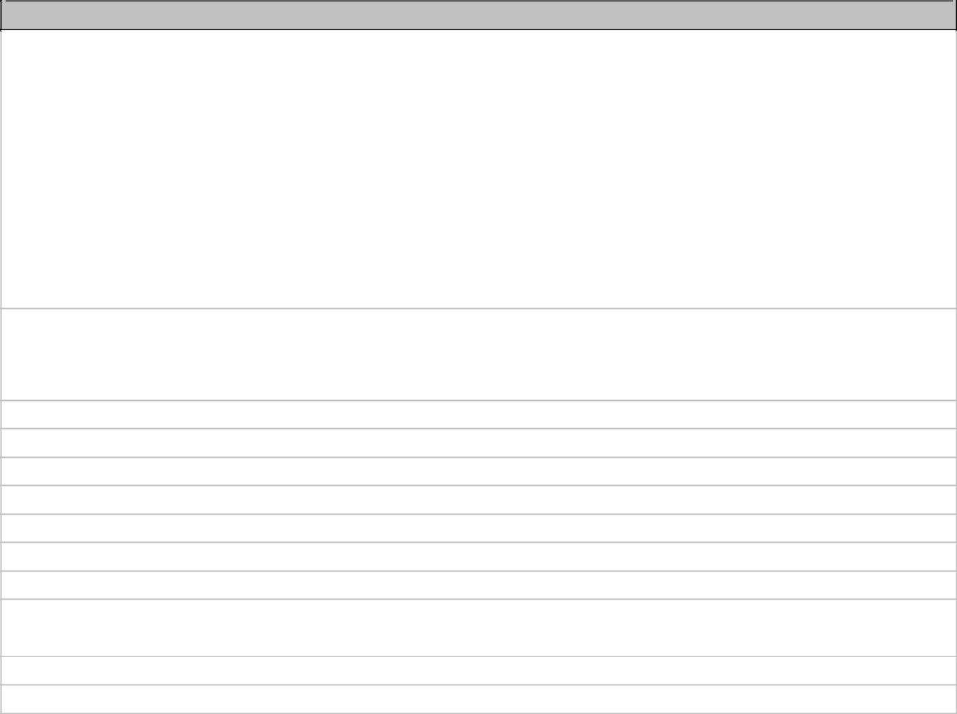

OtherConstraintst
Tumut Shire, like many smaller country Councils is currently, in my opinion, almost besieged by the

impacts of the waves of NSW State Legislation that is placing more responsibilities on local Councils. Much of the legislation gives Councils additional functions and compliance requirements, and none / little of it seems to have associated funding schemes.

I clearly do not understand the situation, but it just may be that sections of the government are of the opinion that NSW Councils can significantly increase their workloads with their existing resources.

On top of this, the game of rate pegging played each year limits a Councils ability to increase its revenue base to fund these additional loads & changes.

This situation places considerable pressure on smaller organisations such as ours and projects are resourced on a priority basis. Whilst I am sure the lead project has seriously important health implications, it is simply another function we have not been able to address. Ken Fletcher

re lack of resources: +ve identification requires lab. Analysis. Most houses 'at risk" are

renovated/repainted without council approval. The inbuilt perception of : 'it's only a small project', "it won't happen to me'.

No immediate need

No demand

Limited demand

Lead Programs run by Broken Hill Environmental Lead Centre.

Lack of staff

Lack of resources (ie NOT a lack of funding)

Lack of interest

It is not a priority of the Councillors. The one LRC trained officer, Janine Feray, has left a few years ago.

"Has not been addressed as far as I can see"

Low incidence of work on lead/general community awareness

Types of Support that would Suit Council

Respondents were asked to rank the types of support that would suit council, either as:-

1= highly preferred 2 = preferred or 3 = not preferred.

Council LEAD Project staff ascribed a further "ranking" for any boxes left blank. Thus:-4 = not ranked
- Networking / liaison with experienced Councils

- A ”How To” kit

Initial Survey Results July 23 July 2001 Page 7 of 11

- Sample materials (eg policies, educational materials)

- Telephone / e-mail support during office hours

- Web based resource materials

- Face to face regional workshops

- In-House training for a whole-of council approach

- Electronic networks / email discussion groups

Preferred Types of Support

100%
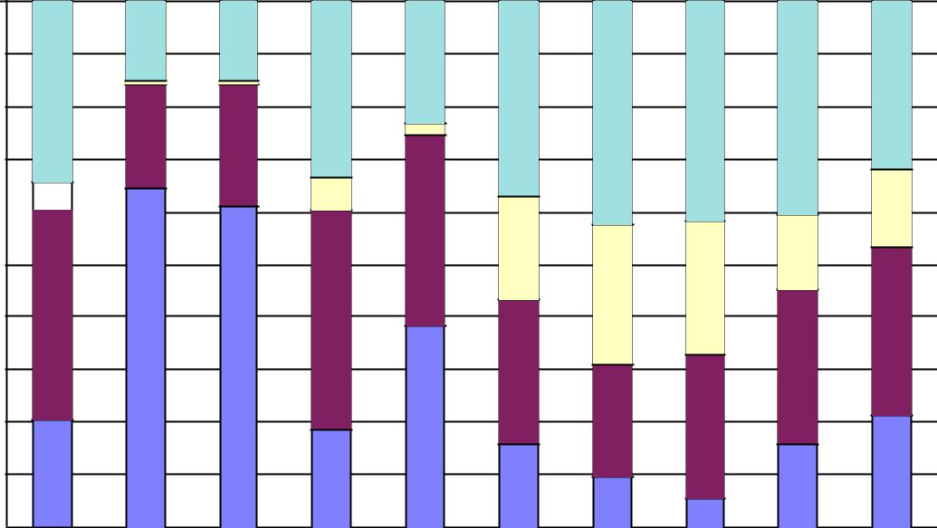

90%

80%

70%

60% 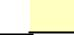

50%

40%

30%

20%

10%

0%

 | Liaison |  |  |  |  | Kit | Materials | InfoLine | Resource |  |  |  | Training | eNetworks | hr Hotline Materials
 |  | -"How |  | to" |  | Kit | -BH |  |  | - Workshops |  |  | - | -24
- Network | 02 |  | - |  | Sample |  | 04 | - Web | 06 |  | - | InHouse | 08 | 09 | - Video
01 |  |  |  |  |  |  |  | 05 |  |  | - |  |  |  | 10
01 |  |  | 03 |  |  |  |  |  |  |  | 07 |  |  |  | 10

Not Ranked
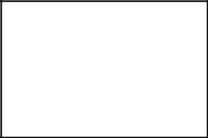

Not Preferred

Preferred Highly Preferred

- 24-hour “hot-line” support for lead inquiries

- Video materials

There were five types of support for which the "Highly preferred" plus "Preferred" votes totalled more than 60% so these five have been graphed (below) to show the breakdown between the different council types:-

- Network Liaison

- A "How to" kit

- Sample materials

- Telephone / email support during office hours (or business hours = BH)

- Web resources

Initial Survey Results July 23 July 2001 Page 8 of 11

Networking/Liaison

100%
90%
80%
70%
60%
60% |  |  |  |  |  |  |  |  |  |  |  |  |  | 4 | - Not Ranked
50% |  |  |  |  |  |  |  |  |  |  |  |  |  | 3 | - Not Preferred
50% |  |  |  |  |  |  |  |  |  |  |  |  |  | 2 | - Preferred
40% |  |  |  |  |  |  |  |  |  |  |  |  |  | 1 | - Highly Preferred
30%
20%
10%
0%
0% |  |  |  | Country |  | Metro |  | Shire

A "How To" Kit

100%
90%
80%
70%
60%
60% |  |  |  |  |  |  |  |  |  |  |  |  |  | 4 | - Not Ranked
50% |  |  |  |  |  |  |  |  |  |  |  |  |  | 3 | - Not Preferred
50% |  |  |  |  |  |  |  |  |  |  |  |  |  | 2 | - Preferred
40% |  |  |  |  |  |  |  |  |  |  |  |  |  | 1 | - Highly Preferred
30%
20%
10%
0%
0% |  |  |  | Country |  | Metro |  | Shire

Initial Survey Results July 23 July 2001 Page 9 of 11
Sample Materials

100%
90%
80%
70%
60%
60% |  |  |  |  |  |  |  |  |  |  |  |  |  | 4 | - Not Ranked
50% |  |  |  |  |  |  |  |  |  |  |  |  |  | 3 | - Not Preferred
50% |  |  |  |  |  |  |  |  |  |  |  |  |  | 2 | - Preferred
40% |  |  |  |  |  |  |  |  |  |  |  |  |  | 1 | - Highly Preferred
30%
20%
10%
0%
0% |  |  |  | Country |  | Metro |  | Shire

Phone/E-Mail Support

100%
90%
80%
70%
60%
60% |  |  |  |  |  |  |  |  |  |  |  |  |  | 4 | - Not Ranked
50% |  |  |  |  |  |  |  |  |  |  |  |  |  | 3 | - Not Preferred
50% |  |  |  |  |  |  |  |  |  |  |  |  |  | 2 | - Preferred
40% |  |  |  |  |  |  |  |  |  |  |  |  |  | 1 | - Highly Preferred
30%
20%
10%
0%
0% |  |  |  | Country |  | Metro |  | Shire

Initial Survey Results July 23 July 2001 Page 10 of 11
Web Resource

100%
90%
80%
70%
60%
60% |  |  |  |  |  |  |  |  |  |  |  |  |  |  | 4 | - Not Ranked
50% |  |  |  |  |  |  |  |  |  |  |  |  |  |  | 3 | - Not Preferred
50% |  |  |  |  |  |  |  |  |  |  |  |  |  |  | 2 | - Preferred
40% |  |  |  |  |  |  |  |  |  |  |  |  |  |  | 1 | - Highly Preferred
30%
20%
10%
0%
0% |  |  |  | Country |  | Metro |  | Shire

The final question in the survey asked for any other preferred types of support and the following results were given:-

OtherSupport

Specific promotional packages for painters, mechanics, D.I.Y people etc.

Score should be construed in the context of other more urgent priorities.

Provision of grants to employ project officers on a Regional basis to develop and implement projects / policies for the Councils in that Region.

Probably a combination of the above.

Other activities might be preferred depending on how the listed preferred and highly preferred items go.

Funding assistance for site investigation and remediation.

Comment on proposed supports: "good ideas".

Any material that can be provided to highlight this problem to the local tradesman would be appreciated & also any suggestions as to prevention of lead contamination & exposure.

Additional funding to facilitate employment of an environmental officer to focus on the subject area [lead]. "$ and someone to do the work"

Initial Survey Results July 23 July 2001 Page 11 of 11

